Push Button / Switch Interfacing to Arduino:
Introduction:
The Push Button:
Push Buttons like LEDs form a common part of most electronics devices. Push buttons can be used to get user feedback. (image a common scenario of scrolling through a menu and selecting an option - there are buttons all around the process!)

Requirment:
- Push Button,
- two Resistor
- Arduino Board

Hardware configuration:

Following step will requried to Push Button / Switch Interfacing to Arduino.

Step1: Before connecting the Button, we need to connect our '+'ve terminal to the 5Volts SUPPLY line on the Arduino. Connect as shown in the image below.

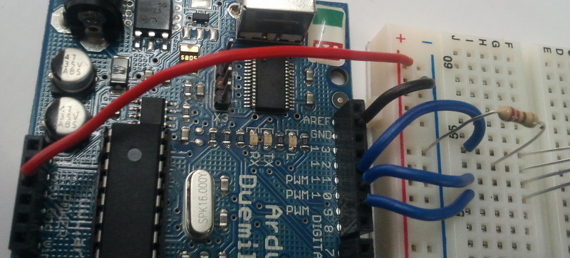
Step2:There are 2 ways to connect a Push Button to the arduino - the Pull-Down Configuration & the Pull-Up Configuration. We will take a look at both these.
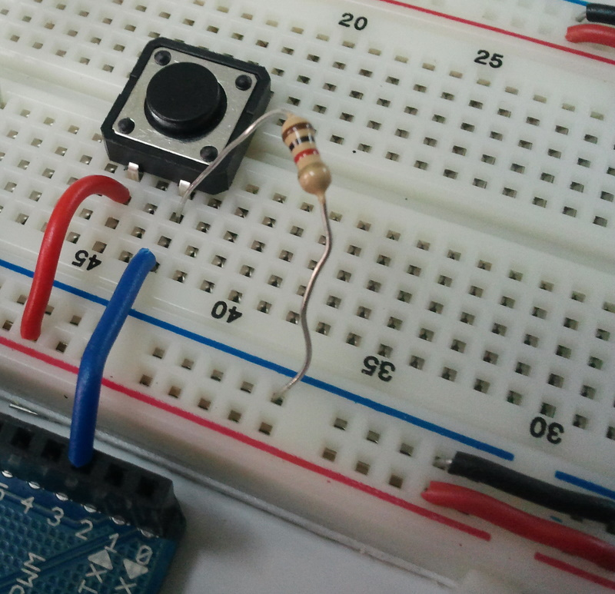
Step3:The Pull-Down Cnfiguration:
In this configuration the Push Button is set-up such that it keeps giving a constant LOW signal(0)
The Pull-Down Configuration
when not being pressed and gives a HIGH signal(1) when being pressed. To ensure that it keeps giving a LOW signal at all times, the Input line is also connect to the '-'ve terminal through a resistor. So in when the button is not being pressed, the input line stays connected to the GROUND. When the button is being pressed (and as the path of low resistance is always preferred) the input line gets connected to the SUPPLY line. Look at the following image to see how to connect a button in this configuration. We will keep this connection only as a reference as we will be using the Pull-Up configuration for our circuits.

Step4:The Pull-UP Cnfiguration:
In this configuration the Push Button is set-up such that it keeps giving a constant HIGH signal(1) when not being pressed and gives a LOW signal(0) when being pressed. To ensure that it keeps giving a HIGH signal at all times, the Input line is also connect to the '+'ve terminal through a resistor. So in when the button is not being pressed, the input line stays connected to the SUPPLY . When the button is being pressed (and as the path of low resistance is always preferred) the input line gets connected to the GROUND line. Look at the following image to see how to connect a button in this configuration. This is the most preferred method to connect a button
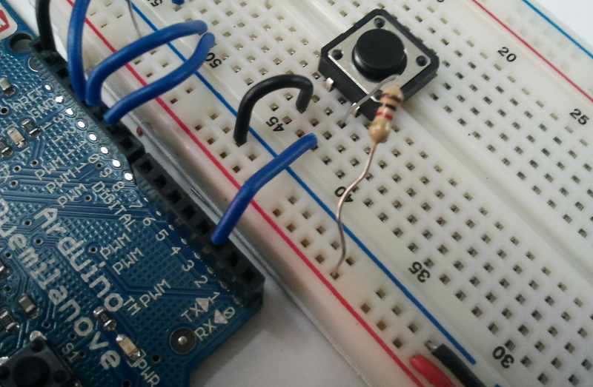
The Pull-Up Configuration

Here's is Final the Output as shown like that:
Programing:(source code)
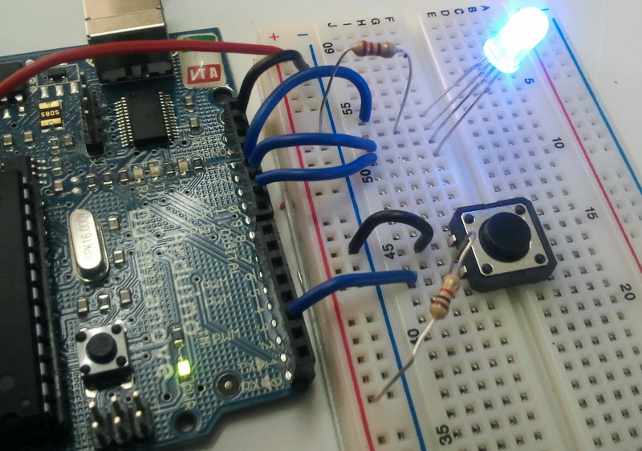

Programing:(source code):
Programming to control the Push Button / Switch:

/*
RGB_Button
Pressing the Button increases the intensity of one colour at a time, once themaximum intensity of the colour is reached
that colour isset to 0 and the intensity of the next colour starts increasing
*/

int intensity = 0, pin = 9;

void setup() {
pinMode(2,INPUT); // This is the pin to which we have connected the button
}

void loop() {
if(digitalRead(2)==0) // check if the button is being pressed
{
Serial.println("here");
if(intensity < 255)
{
intensity++;
}
else
{
intensity=0;
analogWrite(pin,intensity);
if(pin<11)
pin++;
else
pin=9;
}
analogWrite(pin,intensity);
}

}
Installation:
The source code copy to the skeches of arduino and compile (there is verify option) as shown given below.
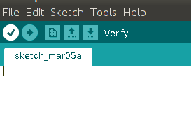

And then uploding the source code.(there is uploding option) to the Arduino board.(software) as shown given below.
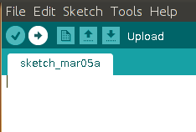

Troubleshooting:
FAQ:
Maintainers:
Duryodhan Aldar (durva.ges@gmail.com)

References: http://quickstartkitforarduino.blogspot.in/

